Enthalpy

The measure of heat energy in a chemical system. This energy is stored in the bonds.

When chemicals react, energy is either taken in (endothermic) or given out (exothermic). This causes an overall energy change, where endothermic reactions gain energy, (positive ΔH) and exothermic reactions lose energy (negative ΔH).

The enthalpy change is the overall change in energy between the products and reactants.

Activation energy is the minimum amount of energy required to start a reaction.

Standard Enthalpies
There are 3 types of standard enthalpies:

Standard enthalpy change of reaction ( Δ_{r}H^{θ} ):
The enthalpy change that accompanies a reaction in the quantities expressed in a chemical equation, under standard conditions.
All reactants and products are in their standard states.

Standard enthalpy change of combustion ( Δ_{c}H^{θ} ):
The enthalpy change that takes place when one mole of a substance completely reacts with oxygen under standard conditions.
All reactants and products are in their standard states.

Standard enthalpy change of formation ( Δ_{f}H^{θ} ):
The enthalpy change that takes place when one mole of a compound is formed from its constituent elements.
All reactants and products are in their standard states.

Bond Enthalpies
These are always positive values, they are the amount of energy required to break the bonds in 1 mole of the substance.

Forming bonds is exothermic.
Breaking bonds is endothermic.

Even when the overall change is positive, the value must be expressed with a '+', e.g. -800kJmol⁻¹ or +800kJmol⁻¹.
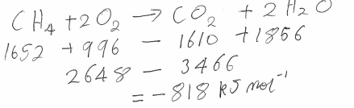
Here, the reaction has an overall change of -818 kJmol⁻¹. This means that the reaction was exothermic, as the substances lost energy to the surroundings.

The bonds given in the exam are just average, so will not be standard enthalpy change values.

